For “How does soap opera change the world?”

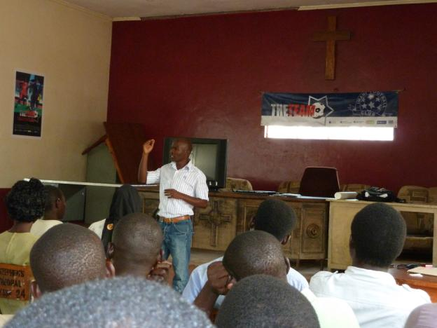
Collins Owvor leads Team outreach session in Kisumu, Kenya

Photo by Deborah Jones

For: Kenya Coffee Bar: Photos by Deborah Jones
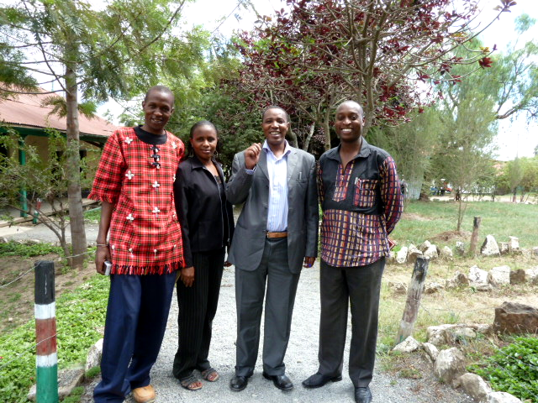
Peter Kairie, Virginia Waimatha,, DC Michael Kiomi, Mburugu Gikunda
DC Michael Kiomi, Mburugu Gikunda

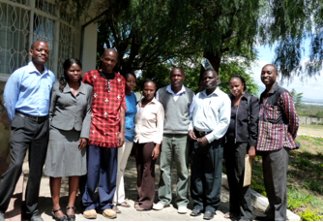
Photo below: Coffee Bar Organizers, Naivasha

